All coverage

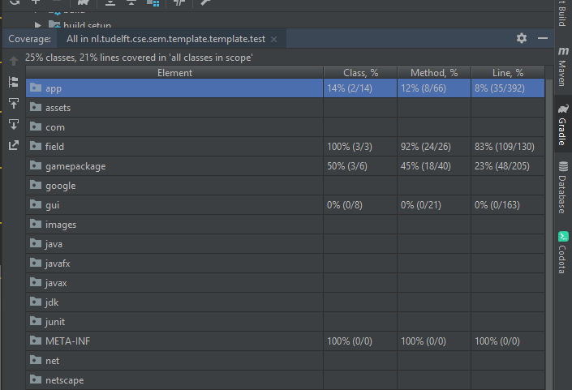

Field package coverage

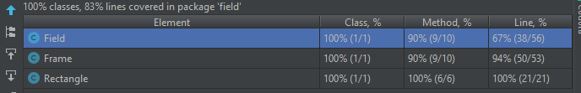

Game package coverage

